**Email-to-Case**  
Automatically turn emails from your customers into cases in Salesforce to track and resolve customer cases quickly  
  
**Email to Case**is a very specific application that allows your customers to send emails that either  
a) Open a new Case b) carry on a threaded conversation about a previously-opened Case via email  
These Cases can have attachments. Inbound email to case email is automatically inserted into a special Sobject called EmailMessage, used only for email to case. This appears as a related list under Case.  
You can then wire in workflows on EmailMessage to enhance your case processing.  
A 100% point and click solution  
  
**InboundEmailServices**is a framework for building any application that can accept emails routed to the email services address. I would not use it for support case business processes as you would have to replicate too much functionality.  
Apex and testmethods required  
  
For Difference please check below post  
1) <http://salesforce.stackexchange.com/questions/49698/differences-between-email-to-case-and-on-demand-email-to-case>  
2) <https://notesbyparth.wordpress.com/2011/09/29/difference-between-on-demand-email-to-case-email-to-case-agent-%E2%80%93-salesforce-com/>  
3) <http://www.infallibletechie.com/2013/06/difference-between-email-to-case-and-on.html>  
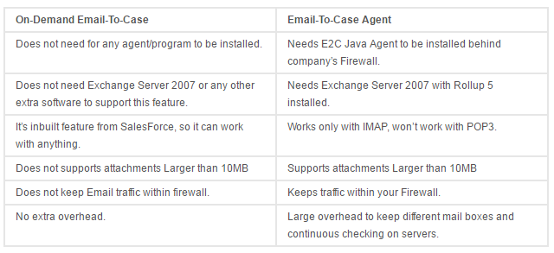

Introducing Email-to-Case

[Help for this Page[https://ajitkumar121-dev-ed.my.salesforce.com/img/s.gif](javascript:openPopupFocusEscapePounds(%27https://login.salesforce.com/services/auth/sso/00D30000000XsfGEAS/HTAuthProvider?startURL=%252Fapex%252Fhtdoor%253Floc%253Dhelp%2526target%253Dcustomizesupport_email.htm%2526section%253DCustomizing%2526language%253Den_US%2526release%253D216.14.1%2526instance%253DAP5&site=https%3A%2F%2Fhelp.salesforce.com%27,%20%27Help%27,%201024,%20768,%20%27width=1024,height=768,resizable=yes,toolbar=yes,status=yes,scrollbars=yes,menubar=yes,directories=no,location=yes,dependant=no%27,%20false,%20false);)](javascript:openPopupFocusEscapePounds(%27https://login.salesforce.com/services/auth/sso/00D30000000XsfGEAS/HTAuthProvider?startURL=%252Fapex%252Fhtdoor%253Floc%253Dhelp%2526target%253Dcustomizesupport_email.htm%2526section%253DCustomizing%2526language%253Den_US%2526release%253D216.14.1%2526instance%253DAP5&site=https%3A%2F%2Fhelp.salesforce.com%27,%20%27Help%27,%201024,%20768,%20%27width=1024,height=768,resizable=yes,toolbar=yes,status=yes,scrollbars=yes,menubar=yes,directories=no,location=yes,dependant=no%27,%20false,%20false);)

With Salesforce, you can efficiently resolve and correspond with customer inquiries via email. Track and view all email threads regarding a customer service issue, and let your customers send inquiries to email addresses that automatically convert customer emails to cases.

Top of Form

|  |  |
| --- | --- |
| |  | | --- | | Email-to-Case | |
|  |
| **Key features and benefits** |
| 1. Customer responses regarding a case are automatically associated with the original case, including any attachments the customer sends.  2. Case reporting measures both inbound and outbound emails by case so that you can see how many emails are exchanged before an issue is resolved.  3. Routing addresses allow you to create multiple email addresses from which the contents of customer emails can be converted to case fields.  4. Assignment Rules, Escalation Rules, Workflow Rules and Auto-Response Rules all work seamlessly with Email-to-Case. |